PROJECT REPORT ON

LIBRARY MANAGEMENT SYSTEM

REPORT SUBMITTED TO
VISHWAKARMA INSTITUTE OF TECHNOLOGY, PUNE FOR THE CP IN DATA STRUCTURE
IN

Engineering and Telecommunication Department

BY
Avanti Joshi – 26 PRN-12414776
Gayatri Joshi – 27 PRN-12412237
Kanishka Tiwari – 38 PRN-12414781
Shlok Katare – 42 PRN-12414751

Class: ENTC Division: B Batch: 2

Batch Teacher

Prof. Dipti P. Pandit

INDEX
Sr. No. | Contents | Page No.
1 | ABSTRACT | 1
2 | INTRODUCTION AND THEORY | 2-3
3 | FLOW OF PROGRAM | 4-6
4 | SOURCE CODE OF THE PROGRAM | 7-14
5 | OUTPUT | 15
6 | LIST OF THE TOPICS/ CONCEPT WHICH ARE  COVERED FROM THE SYLLABUS | 18
7 | LIST OF THE TOPICS/ CONCEPT WHICH ARE  OUT OF SYLLABUS | 19
8 | CONCLUSION | 20
9 | REFERENCES | 21

ABSTRACT:

The Library Management System is a simple Java-based application designed to manage the daily operations of a library efficiently. This project focuses on applying Object-Oriented Programming (OOP) concepts such as abstraction, inheritance, encapsulation, and polymorphism in a practical way.

The system allows the librarian to perform key operations like adding new books, removing books, and listing all available books. Members can be added to the library and can borrow or return books easily. Each book has a unique ISBN number, and the system keeps track of the total and available copies of each book. It also ensures that a book can only be removed if all its copies are available (i.e., none are borrowed).

The project uses classes such as Book, Member, Librarian, and Library to model real-world entities, showing the use of composition and encapsulation. The menu-driven console interface allows users to interact with the system conveniently, making it simple to perform all library-related tasks.

Overall, this project demonstrates how OOP principles can be used to build a small yet powerful system that organizes and automates basic library functions in an efficient and user-friendly manner

INTRODUCTION AND THEORY:

The Library Management System is a console-based Java application developed to simplify and digitalize the process of managing a library. In traditional libraries, keeping records of books, members, issued books, and returns manually is time-consuming and prone to errors. This project aims to automate these processes using the concepts of Object-Oriented Programming (OOP).

The system allows a librarian to add, remove, and view books, and allows members to borrow or return books efficiently. Each book has a unique ISBN number, and the system keeps track of the total and available copies. Similarly, each member has a unique ID and can borrow a limited number of books at a time.

This project demonstrates how Java’s OOP features—Abstraction, Encapsulation, Inheritance, and Polymorphism—can be used to design a structured, maintainable, and real-world software solution. The program also provides a simple Menu-driven interface* that helps users interact with the system easily.

The project is designed using Object-Oriented Programming (OOP) principles, where the entire system is divided into multiple classes, each representing a real-world entity in a library. The major theoretical concepts used are:

1. Abstraction

- Achieved through the abstract class User, which hides unnecessary details and provides a common structure for different types of users (Member and Librarian).
- It allows focusing on essential operations like viewing user info, without worrying about implementation details.

2. Encapsulation

- Used in the Book and Library classes where data members are kept private and accessed through public methods (getters/setters).
- This protects the data and prevents unauthorized modification of book or member information.

3. Inheritance

- The Member and Librarian classes inherit from the base abstract class User.
- This allows both classes to share common properties (like name and userId) and behaviors while adding their own unique features.

4. Polymorphism

- Achieved through the showInfo () method, which is defined in the abstract User class and overridden in both Member and Librarian classes.
- This enables different behaviours for different types of users while using the same method name.

5. Composition

- The Library class contains collections (maps) of Book and Member objects, showing a “has-a” relationship.
- This means a Library has many Books and Members.

6. Data Structures Used

- HashMap is used to store and manage books (by ISBN) and members (by ID).
- HashSet is used to store the list of borrowed book ISBNs for each member, avoiding duplicates.

7. User Interaction (Menu-Driven Interface)

- The program uses a simple console-based menu system with a Scanner class to take user input and perform tasks like adding books, borrowing, or returning them.
FLOW OF PROGRAM:

The Library Management System follows a step-by-step flow that allows both the librarian and library members to perform various operations easily. The program begins with initialization, followed by a continuous menu-driven interaction with the user until they choose to exit.

1. Start of the Program

The program starts by creating a Library object and a Librarian object (named Admin).
Some sample books and members are added initially to demonstrate the system.

2. Display Main Menu

A menu is displayed to the user with multiple options such as:

1. Add Book
2. Remove Book
3. List Books
4. Add Member
5. List Members
6. Borrow Book
7. Return Book
8. Find Book by ISBN
0. Exit

The user is then prompted to enter their choice.

---

3. User Input and Action

Based on the entered choice, a specific operation is performed:

Option 1 (Add Book):
The librarian enters the book’s ISBN, title, author, and number of copies.
The new book is added to the library database.

Option 2 (Remove Book):
The librarian enters the ISBN of the book to remove.
The book is removed only if all copies are available (no copies borrowed).

Option 3 (List Books):
Displays all books along with their details — title, author, ISBN, and available copies.

Option 4 (Add Member):
Adds a new member by entering their name and ID number.

Option 5 (List Members):
Shows all registered members and the number of books each has borrowed.

Option 6 (Borrow Book):
The member enters their ID and the ISBN of the book they want to borrow.
The system checks if the book is available and if the member hasn’t exceeded the borrow limit.
If valid, the book is issued and available copies decrease by one.

Option 7 (Return Book):
The member enters their ID and ISBN of the book they want to return.
The book’s availability is updated (available copies increase).

Option 8 (Find Book by ISBN):
Displays details of a specific book by entering its ISBN.

4. Looping Back to Menu

After performing each operation, the program returns to the main menu.
The user can continue performing actions until they select 0 (Exit).

5. Program Termination

When the user chooses 0, the program stops running and displays “Goodbye!” before exiting.
Flow Summary (Stepwise)

1. Program starts → Library and Admin initialized
2. Menu displayed → User selects an option
3. System performs requested operation
4. Updated data displayed to user
5. Menu repeats until user exits
6. Program ends

SOURCE CODE OF THE PROGRAM:

import java.util.*;

// Library Management System - Single file, menu-driven, OOP-focused
// Compile: javac LibraryApp1.java
// Run: java LibraryApp1

public class LibraryApp {

// ======== ABSTRACT CLASS (Abstraction) ======== (BASE CLASS) (PARENT CLASS)
static abstract class User {
protected String name;
protected int userId;

public User(String name, int userId) {
this.name = name;
this.userId = userId;
}

public String getName() { return name; }
public int getUserId() { return userId; }

public abstract void showInfo(); // Polymorphism (overridden by subclasses)
}

// ======== MEMBER (Inheritance) ========
static class Member extends User {
private Set<String> borrowedIsbns = new HashSet<>();
private int borrowLimit = 5;

public Member(String name, int userId) {
super(name, userId);
}

public boolean canBorrow() {
return borrowedIsbns.size() < borrowLimit;
}

public void addBorrowed(String isbn) {
borrowedIsbns.add(isbn);
}

public boolean removeBorrowed(String isbn) {
return borrowedIsbns.remove(isbn);
}

public boolean hasBorrowed(String isbn) {
return borrowedIsbns.contains(isbn);
}

public Set<String> getBorrowedIsbns() {
return Collections.unmodifiableSet(borrowedIsbns);
}

@Override
public void showInfo() {
System.out.println("Member: " + name + " (ID: " + userId + "), Borrowed: " + borrowedIsbns.size());
}
}

// ======== LIBRARIAN (Inheritance) ========
static class Librarian extends User {
private final Library library;

public Librarian(String name, int userId, Library library) {
super(name, userId);
this.library = library;
}

public void addBook(Book book) {
library.addBook(book);
System.out.println("Librarian " + name + " added: " + book.getTitle());
}

public boolean removeBookByIsbn(String isbn) {
boolean ok = library.removeBookByIsbn(isbn);
if (ok) {
System.out.println("Librarian " + name + " removed book with ISBN " + isbn);
} else {
System.out.println("No such ISBN or copies still borrowed.");
}
return ok;
}

@Override
public void showInfo() {
System.out.println("Librarian: " + name + " (ID: " + userId + ")");
}
}

// ======== BOOK (Encapsulation) ========
static class Book {
private final String isbn; // unique id
private final String title;
private final String author;
private int totalCopies;
private int availableCopies;

public Book(String isbn, String title, String author, int copies) {
if (isbn == null || isbn.isEmpty()) throw new IllegalArgumentException("ISBN required");
if (copies <= 0) throw new IllegalArgumentException("Copies must be > 0");
this.isbn = isbn.trim();
this.title = title == null ? "" : title.trim();
this.author = author == null ? "" : author.trim();
this.totalCopies = copies;
this.availableCopies = copies;
}

public String getIsbn() { return isbn; }
public String getTitle() { return title; }
public String getAuthor() { return author; }
public int getTotalCopies() { return totalCopies; }
public int getAvailableCopies() { return availableCopies; }

public boolean isAvailable() {
return availableCopies > 0;
}

public boolean borrowOne() {
if (availableCopies > 0) {
availableCopies--;
return true;
}
return false;
}

public void returnOne() {
if (availableCopies < totalCopies) {
availableCopies++;
}
}

public void addCopies(int n) {
if (n <= 0) return;
totalCopies += n;
availableCopies += n;
}

@Override
public String toString() {
return String.format("%s | %s | %s | %d/%d available",
isbn, title, author, availableCopies, totalCopies);
}

// Equality by ISBN (helps if you ever use Sets/Maps of Book)
@Override
public boolean equals(Object o) {
if (this == o) return true;
if (!(o instanceof Book)) return false;
Book b = (Book) o;
return isbn.equals(b.isbn);
}

@Override
public int hashCode() {
return Objects.hash(isbn);
}
}

// ======== LIBRARY (Composition + Encapsulation) ========
static class Library {
private final Map<String, Book> booksByIsbn = new HashMap<>();
private final Map<Integer, Member> membersById = new HashMap<>();

// Book operations
public void addBook(Book book) {
Book existing = booksByIsbn.get(book.getIsbn());
if (existing == null) {
booksByIsbn.put(book.getIsbn(), book);
} else {
existing.addCopies(book.getTotalCopies());
}
}

// Only allow removal if all copies are available (nothing on loan)
public boolean removeBookByIsbn(String isbn) {
Book b = booksByIsbn.get(isbn);
if (b == null) return false;
if (b.getAvailableCopies() != b.getTotalCopies()) return false;
booksByIsbn.remove(isbn);
return true;
}

public Book findBook(String isbn) {
return booksByIsbn.get(isbn);
}

public Collection<Book> allBooks() {
return booksByIsbn.values();
}

// Member operations
public boolean addMember(Member m) {
if (membersById.containsKey(m.getUserId())) return false;
membersById.put(m.getUserId(), m);
return true;
}

public Member getMember(int userId) {
return membersById.get(userId);
}

public Collection<Member> allMembers() {
return membersById.values();
}

// Transactions
public boolean borrowBook(int memberId, String isbn) {
Member mem = membersById.get(memberId);
if (mem == null) {
System.out.println("No such member id.");
return false;
}
Book b = booksByIsbn.get(isbn);
if (b == null) {
System.out.println("No such book ISBN.");
return false;
}
if (!mem.canBorrow()) {
System.out.println("Borrow limit reached for member " + mem.getName());
return false;
}
if (!b.isAvailable()) {
System.out.println("Book not available right now.");
return false;
}
boolean ok = b.borrowOne();
if (ok) {
mem.addBorrowed(isbn);
System.out.println(mem.getName() + " borrowed \"" + b.getTitle() + "\"");
return true;
}
return false;
}

public boolean returnBook(int memberId, String isbn) {
Member mem = membersById.get(memberId);
if (mem == null) {
System.out.println("No such member id.");
return false;
}
Book b = booksByIsbn.get(isbn);
if (b == null) {
System.out.println("No such book ISBN.");
return false;
}
if (!mem.hasBorrowed(isbn)) {
System.out.println("This member did not borrow that book.");
return false;
}
mem.removeBorrowed(isbn);
b.returnOne();
System.out.println(mem.getName() + " returned \"" + b.getTitle() + "\"");
return true;
}
}

// ======== MENU (Console UI) ========
public static void main(String[] args) {
Scanner sc = new Scanner(System.in);
Library library = new Library();
Librarian admin = new Librarian("Admin", 1, library);

// Seed some data
admin.addBook(new Book("978-0134685991", "Effective Java", "Joshua Bloch", 3));
admin.addBook(new Book("978-0596009205", "Head First Java", "Kathy Sierra", 2));
library.addMember(new Member("Avanti", 101));
library.addMember(new Member("Gayatri", 102));

System.out.println("=== Library Management System ===");
boolean running = true;

while (running) {
printMenu();
int choice = readInt(sc, "Enter choice: ");

switch (choice) {
case 1: // Add book
System.out.println("Add Book");
String isbn = readLine(sc, "ISBN: ");
if (library.findBook(isbn) != null) {
System.out.println("❌ Book with this ISBN already exists!");
break;
}
try {
admin.addBook(new Book(isbn,
readLine(sc, "Title: "),
readLine(sc, "Author: "),
readInt(sc, "Copies (>0): ")));
System.out.println("✅ Book added!");
} catch (IllegalArgumentException e) {
System.out.println("Error: " + e.getMessage());
}
break;

case 2: // Remove book
System.out.println("Remove Book");
String rIsbn = readLine(sc, "ISBN to remove: ");
admin.removeBookByIsbn(rIsbn);
break;

case 3: // List books
System.out.println("Books:");
for (Book b : library.allBooks()) {
System.out.println(" " + b);
}
break;

case 4: // Add member
System.out.println("Add Member");
String mName = readLine(sc, "Member name: ");
int mId = readInt(sc, "Member id (int): ");
Member m = new Member(mName, mId);
if (library.addMember(m)) {
System.out.println("Added member: " + mName + " (ID " + mId + ")");
} else {
System.out.println("Member ID already exists.");
}
break;

case 5: // List members
System.out.println("Members:");
for (Member mem : library.allMembers()) {
mem.showInfo();
if (!mem.getBorrowedIsbns().isEmpty()) {
System.out.println(" Borrowed: " + mem.getBorrowedIsbns());
}
}
break;

case 6: // Borrow
System.out.println("Borrow Book");
int bmId = readInt(sc, "Member id: ");
String bIsbn = readLine(sc, "Book ISBN: ");
library.borrowBook(bmId, bIsbn);
break;

case 7: // Return
System.out.println("Return Book");
int rmId = readInt(sc, "Member id: ");
String rbIsbn = readLine(sc, "Book ISBN: ");
library.returnBook(rmId, rbIsbn);
break;

case 8: // Find book by ISBN
String fIsbn = readLine(sc, "Find Book - Enter ISBN: ");
Book fb = library.findBook(fIsbn);
if (fb == null) System.out.println("Not found.");
else System.out.println(fb);
break;

case 0:
running = false;
break;

default:
System.out.println("Invalid choice.");
}
System.out.println();
}

System.out.println("Goodbye!");
}

private static void printMenu() {
System.out.println("---------------------------------");
System.out.println("1. Add Book");
System.out.println("2. Remove Book (only if all copies available)");
System.out.println("3. List Books");
System.out.println("4. Add Member");
System.out.println("5. List Members");
System.out.println("6. Borrow Book");
System.out.println("7. Return Book");
System.out.println("8. Find Book by ISBN");
System.out.println("0. Exit");
}

private static String readLine(Scanner sc, String prompt) {
System.out.print(prompt);
String line = sc.nextLine();
while (line.trim().isEmpty()) {
System.out.print(prompt);
line = sc.nextLine();
}
return line.trim();
}

private static int readInt(Scanner sc, String prompt) {
while (true) {
System.out.print(prompt);
String s = sc.nextLine().trim();
try {
return Integer.parseInt(s);
} catch (NumberFormatException e) {
System.out.println("Please enter a valid integer.");
}
}
}
}
OUTPUT:

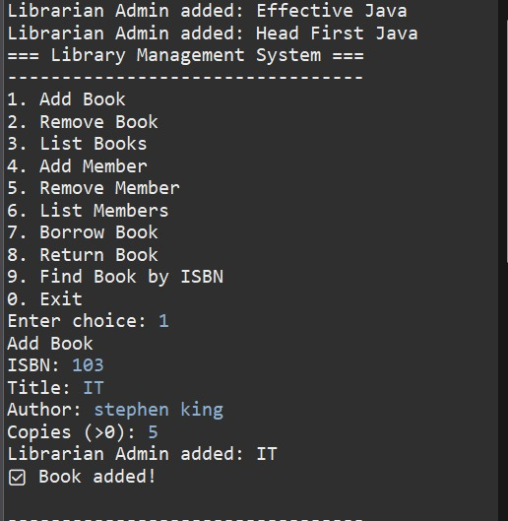

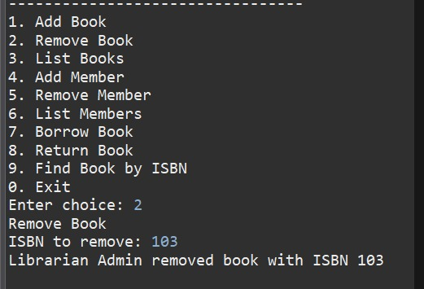

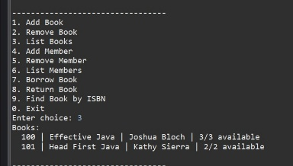
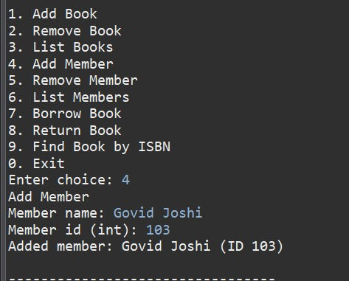

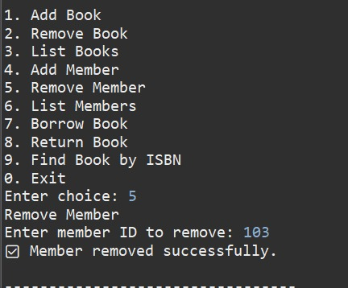

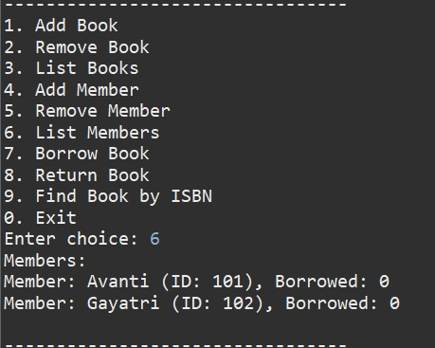


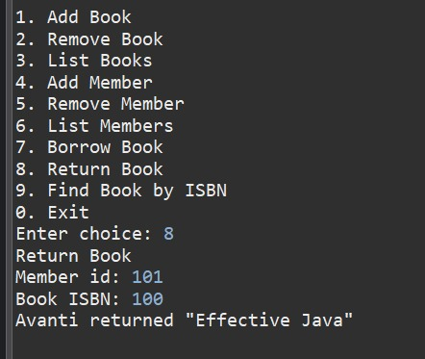

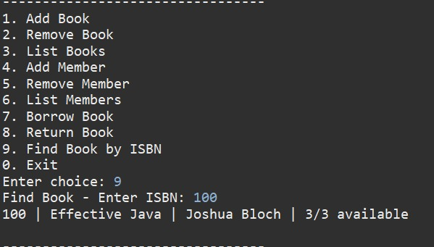

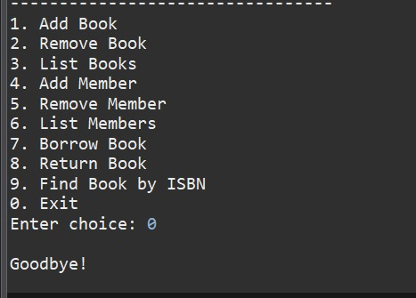
LIST OF THE TOPICS/ CONCEPT WHICH ARE COVERED FROM THE SYLLABUS:

The Library Management System project covers various Object-Oriented Programming (OOP) and Core Java concepts from the syllabus. The key topics and concepts applied in this project are:

1. Object-Oriented Programming Concepts

Class and Object – Used to represent real-world entities such as Book, Member, Librarian, and Library.

Abstraction – Implemented using the abstract class User, which hides implementation details and provides a general structure for users.

Encapsulation – Achieved by making class data members private and accessing them through public methods (getters/setters).

Inheritance – The classes Member and Librarian inherit from the base class User.

Polymorphism – Demonstrated using method overriding (showInfo() method behaves differently for each subclass).

Composition – The Library class contains and manages multiple Book and Member objects.

2. Java Programming Concepts

Access Modifiers (public, private, protected) – Used to control visibility and maintain data security.

Constructors – Used to initialize objects like books and members.

Exception Handling – IllegalArgumentException is used for handling invalid inputs such as negative copies or empty ISBN.

String Handling – Methods like .trim(), .equals(), and .isEmpty() are used for string validation.

Collections Framework –

HashMap used to store books and members with unique keys (ISBN and ID).

LIST OF THE TOPICS/ CONCEPT WHICH ARE OUT OF SYLLABUS:

HashSet used to store borrowed book ISBNs for each member.

Collection and Set interfaces used for data retrieval and iteration.

Scanner Class – Used for taking user input from the console.

3. Programming Structure and Logic

Menu-Driven Program – Provides a simple interactive text-based user interface for performing library operations.

Control Structures – if, else, switch, and while loops used for program logic and flow control.

Functions / Methods – Modular programming approach used for clarity and reusability.

Static Methods – Used for helper functions like printMenu(), readLine(), and readInt().

4. Software Development Principles

Modularity – The system is divided into multiple independent classes, each handling a specific responsibility.

Reusability and Maintainability – The code structure allows easy modification and extension for future updates.

Error Handling and Validation – Input data is checked to prevent invalid operations (e.g., removing borrowed books)
CONCLUSION:

The Library Management System project successfully demonstrates the implementation of Object-Oriented Programming (OOP) concepts using Java in a real-world application. Through this project, all major OOP principles such as abstraction, encapsulation, inheritance, and polymorphism have been effectively applied to design a modular, reusable, and well-structured system.

The system efficiently manages key library operations such as adding, removing, borrowing, and returning books, along with member management. It also ensures proper validation and error handling to maintain data consistency and reliability.

Developing this project provided valuable learning experience in Java programming, data structures (HashMap, HashSet), and logical problem-solving. It also helped in understanding how theoretical OOP concepts can be implemented in practical software systems.

Overall, the project enhances understanding of both software design principles and real-world system development, serving as a strong foundation for building more advanced management applications in the future
REFERENCES:

Herbert Schildt, Java: The Complete Reference, 9th Edition, McGraw-Hill Education, 2019.
→ Used for understanding Java syntax, classes, objects, and encapsulation concepts.

E. Balagurusamy, Programming with Java: A Primer, 5th Edition, McGraw-Hill Education, 2017.
→ Helped in understanding object-oriented programming principles like inheritance, polymorphism, and encapsulation.

Oracle Official Documentation, Java Platform, Standard Edition Documentation,
Available at: https://docs.oracle.com/javase/

→ Used for syntax clarification and built-in library functions (e.g., Map, HashMap, Scanner, Objects).

W3Schools, Java OOP Concepts Tutorial,
Available at: https://www.w3schools.com/java/java_oop.asp

→ Referred to for understanding practical applications of OOP concepts.

GeeksforGeeks, Java Programming and Data Structures Tutorials,
Available at: https://www.geeksforgeeks.org/java/

